CE Checklist for Door Company’s

The checklist

Every door company is responsible for CE marking on the delivered products. CE marking consist of 3 main topics. The door company is responsible for the CE complete administration of his doors available on the market.

# The Construction File

* Declaration of Performance of the door
* Declaration of conformity (Only for power operated doors)
* Initial type testing report with life span testing (30.000-100.000 cycles)
* Risk assessment for the door
* Bill of Material (all used parts, electric motor, panels, hardware etc.)
* Declarations of incorporation for all safety related parts (or make sure that the documents are made available at your request)
* RoHS Declaration from suppliers of electrical equipment that contain hazardous substances
* REACH Declaration from supplier of parts that contain chemical substances
* Manual for installation, use, repair and dismantling, In language of end users

# The CE label

Information by Door Company

* + Address data
  + Year of production
  + Unique identification number
  + Mechanical stability construction, *Pass*

Information by a notified body (from initial type testing report)

* + Water tightness class
  + Wind load class
  + Thermal resistance
  + Safe opening

Testing conditions

* + Durability, Lifespan test cycles
  + Operating forces for power operated doors

Directives

* + Mention national/local directives applied to the door

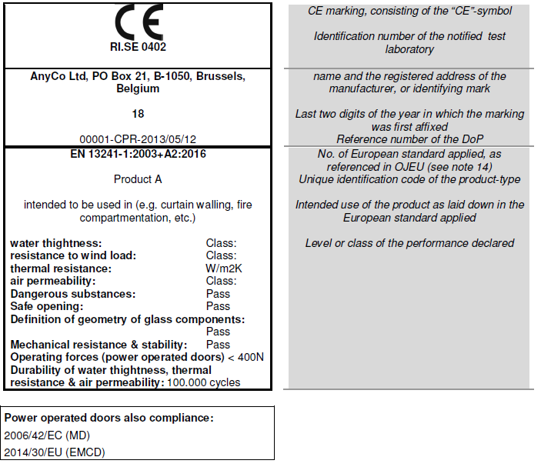

# Factory production control

* Make sure to have factory production control when producing, assembling the door.

# End user receives

* User manual in the language of the end user or language required by the EU-member state (including an extract of the declaration of performance/conformity)
* EU-Declaration of Performance, signed by the installer (and Declaration of Conformity in case of power operated doors).
* Dismantling manual
* Instruct the end user personally how to operate, use and maintain the door.
* CE label on the door